
Graffiti Busters
Lab 2
Queries, Views and DML
Objectives:

- Queries
- Create and use views with queries
- Use DML to insert, update and delete records.

Requirements:

- Use the SQL script called ‘Lab2BData.sql’ to populate some of your database tables.

- Write the following queries. You may wish to modify the test data given to you in Lab2BData.sql in order to test your queries completely.

  - Select the first name, last name (as one column) and phone number from client with client id 4. (1 mark)

  - For all clients, select the client first name, last name and the number of jobs they have. (3 marks)

  - Select the average CostPerHour of the services.(1 mark)

  - Create a single list of all the client and staff first names and last names in descending order by last name.(2 marks)

  - Select the supply code and description for all the supplies that have been used on more than 2 jobs.(4 marks)

  - Select jobnumber, date, full address(one column), sub, GST, total, staff name (one column), client name (one column) and phone number for job number 2. (3 marks)

  - Select all the supply descriptions whose category code starts with “P”. (2 marks)

  - Select the supply code and description of the supplies that have never been used on a job.(2 marks)

  - Select the first name, last name of the staff member who has taken the most number of training courses. You must use a subquery.(4 marks)

  - Hard work has its rewards! On the last day of each month the staff member who worked on the job with the highest individual total in that month wins a $25 Tim Hortons gift card! Select the first name and the last name (one column) of that staff member.(4 marks)

  - How many supplies are there in each supply category? Select the supplycategorycode, description and the count.(3 marks)

Views
- Create a view called ClientJobServices that contains ClientID, FirstName, LastName, Phone, JobNumber, Date, SubTotal, GST, Total, Description, Hours for all clients that had jobs.
(2 marks)

- Using the ClientJobServicesView select the ClientID, FirstName,LastName, and the total amount of GST each client has paid.
(2 marks)

DML:

- Insert the following records in the service table given the following data:
(1 marks)

ServiceCode | Description | CostPerHour
Siding10  Scraping15 | Basic Siding  Scraping | 45  15

- Increase the CostPerHour of all the services that have the word Construction in their description by 10%. (2 marks)

- Change the description to Basic Priming and the CostPerHour to 15.00 for the Service with ServiceCode Prime1 (2 marks)

- Delete the services whose CostPerHour are between 25.00 and 45.00. (2 marks)

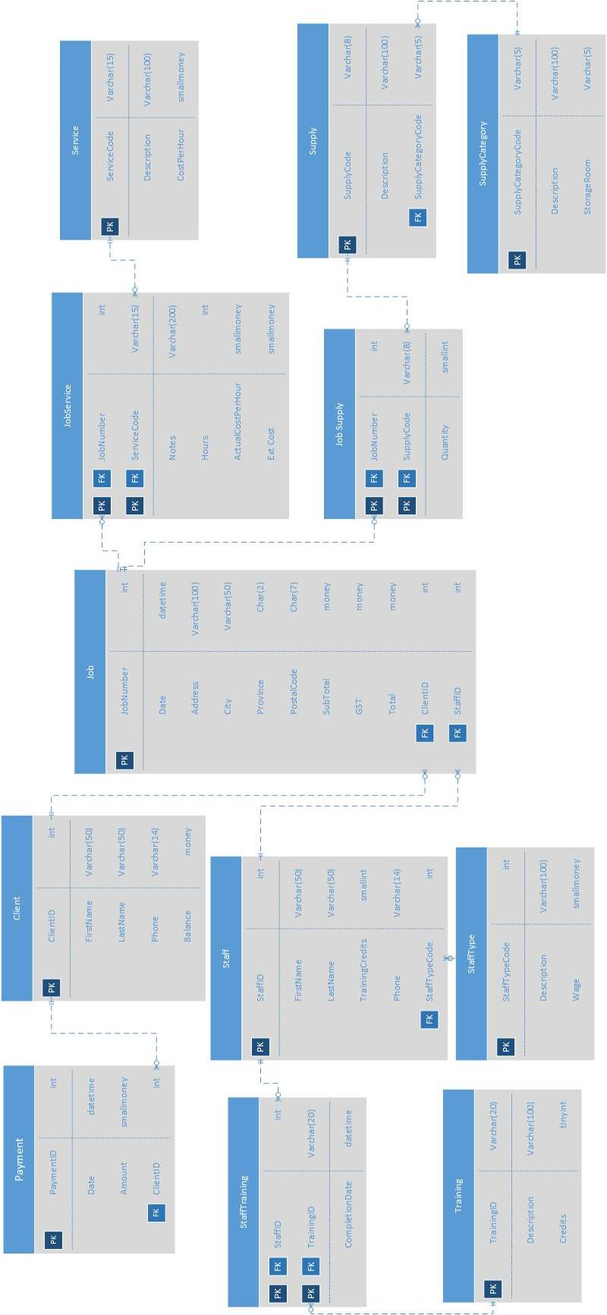
APPENDIX
Lab Submission is to include the following:

- Create a single script file called “Lab2BSolution.sql” that contains a clearly commented batch of statements for each requirement. Each batch will contain the SQL statement(s) required to complete the question. DO NOT include anything else (test data, random comments, etc.). The entire script should be able to run at once.
- If there are any known errors in your solution you must identify them at the top of your script in comments. Errors you have identified and simply could not find a solution for are more acceptable than undocumented errors. Failure to document known errors will result in mark ½ mark deduction for each undocumented error up to 3 marks.

- Your script file will be submitted to moodle (or other location if specified by your instructor).

- Any additional requirements as specified by your instructor.

Other Considerations
Do not make assumptions. If you have questions about the company, ask your instructor (client). This is not a group project. Working with another student on lab material may result in a grade of 0 for this lab. Up to 3 Marks may be deducted for incomplete lab submission requirements or poor client communication (check the provided documentation for the answer before asking the client).

